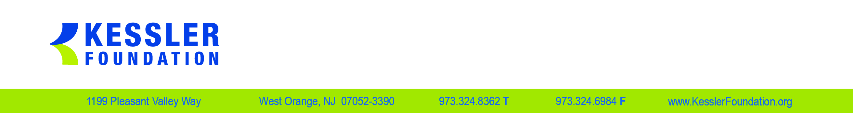

Reliance Agreement To Name Kessler Foundation IRB The Single IRB of Record For A Multi-Site Collaborative Research Study

This agreement is between Kessler Foundation,120 Eagle Rock Ave, Suite 100, East Hanover, N.J. 07936 (Institution A) and__________________________________ (Institution B). Both institutions are participating in the multi-site, collaborative research study:
Title ____________________________________________________________________
Principal Investigator Name_______________________ Institution__________________
Sponsor_________________________________________________________________

As part of its role in this collaborative study, Institution B agrees to delegate the IRB function for this study at its institution to the single IRB of record for the study, the Kessler Foundation IRB (KF-IRB). In agreeing to delegate the IRB function for this study to the KF-IRB, Institution B agrees to the following:

- Carrying out the collaborative research study in compliance with all DHHS-Office of Human Research Protection regulations on human subjects’ protection as detailed in 45CFR part 46 and in compliance with state and local laws. The site Principal Investigator at Institution B is the individual primarily responsible for conducting the study in compliance with federal regulations and state and local laws.

- Submitting an initial application form and consent forms(s) to be used at Institution B to KF-IRB as part of the initial application submission for review and action by KF-IRB.

- Using the KF-IRB written consent form template customized to address local circumstances to enroll subjects in the study at Institution B. Proposed customized changes will be reviewed and approved by KF-IRB

- Submitting to the KF-IRB an annual continuation application for the study including a copy of the currently approved consent form being used at Institution B.

- Submitting to the KF-IRB for review and approval any proposed amendment to the approved study.

- Submitting to KF-IRB for review within 48 hours of any serious adverse event that occurred to an enrolled subject at Institution B.

- Submitting to KF-IRB for review within 5 business days of any adverse event of moderate or greater severity associated with the intervention that occurred at Institution B.

- Submitting to KF-IRB within 5 business days any instances of protocol deviations or non-compliance that occurred at Institution B.

- Submitting to KF-IRB for approval in advance for any proposed changes (exceptions) to the protocol for an individual subject at Institution B.

- Participating in an annual audit of de-identified research records of a random sample of study subjects enrolled at the external institution. The audit will be done by KF-IRB staff using de-identified research records sent to KF-IRB either in hard copy or electronically. The results of the audit will be sent to the participating institution including requests to remedy any deficiencies identified.

- Reimbursement to Kessler Foundation for costs associated with KF-IRB assuming the IRB functions for all participating institutions in this multi-site study will be arranged before the study begins, either by including these costs as direct costs to the grant or contract supporting the study, or by a reimbursement schedule whereby each participating site reimburses Kessler Foundation $3,000 for the initial IRB review and $1,000 annually for the continuation reviews.

Signatories to this agreement:

Institution B:
Name: Signature and date: ______________________________
Title:
Email Address:
Phone Number:

Kessler Foundation:
Name: John DeLuca, Ph.D. Signature and date: _____________________________
Title: SVP for Research
Email Address: jdeluca@kesslerfoundation.org
Phone Number: 973-324-3572

Site Principal Investigators:

Institution B Kessler Foundation
Name:
Title:
Email Address
Phone Number

Contact Persons at IRBs
Name: Donna Servidio
Title: IRB Manager
Email Address dservidio@kesslerfoundation.org
Phone Number 973-243-6972

IRB FWA # 00001357
Expiration Date 4.19.22

