KESSLER FOUNDATION

National Employment & Disability Survey: Recent College Graduates
MEET OUR EXPERTS
2020

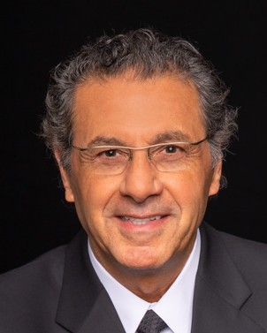
Rodger DeRose
President & Chief Executive Officer
Rodger DeRose oversees the strategic direction of Kessler Foundation, widely recognized for improving the lives of people with disabilities through innovation in medical rehabilitation research, and its commitment to funding programs that expand employment opportunities. Under his leadership, the Foundation has made strategic investments in innovative technology and expanded partnerships and collaborations, resulting in awards of more than $70 million in external grant funding from government and private agencies. Since 2012, the Foundation has been recognized annually with state and national awards for workplace excellence.
DeRose has 30 years of experience in the for-profit sector, first working as senior marketing executive at SC Johnson before becoming partner and chief operating officer for Arthur Andersen’s Technology Software Division. In 2001, he went on to serve as president and CEO of the Crohn’s & Colitis Foundation of America. DeRose currently serves on the board of the Perlman Music Program NY and Suncoast Program, and is often sought after by media for his expertise in organizational management and leadership.

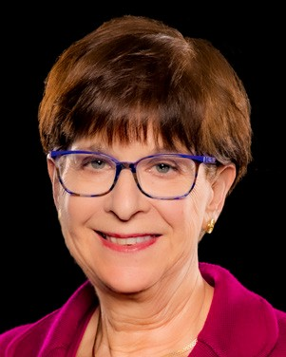
Elaine E. Katz, MS, CCC-SLP Senior VP, Center for Grants and Communication
Elaine Katz oversees Kessler Foundation’s comprehensive grant making program and its communications department. During her tenure, the Foundation has awarded more than $49 million in grant support for national and community-based employment programs.
For more than 25 years, Katz has worked with non-profit organizations in the areas of board development, fundraising, marketing, and business development. Katz often speaks about innovative practices for employing people with disabilities, and is the author/co-author of articles and papers on related topics. She currently serves on the board of directors of JESPY House, New Jersey Association of People Supporting Employment First (NJAPSE), Essex/Newark Disabilities Issues Committee, and on the program committee of the Council of NJ Grantmakers. Elaine served as a member of the Human and Children Services Transition Advisory Committee for Governor-elect Phil Murphy. She is also an appointed member of Empower NYC Advisory Board, Workforce Matters National Steering Committee, ReelAbilities NY Advisory & Council, ReelAbilities 2019 Selection Committee and the NJ Veterans and Community Collaborative Network (VCCN).

John O’Neill, PhD, CRC
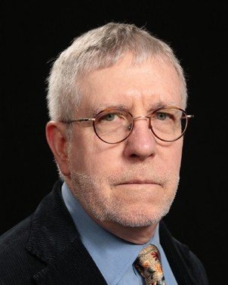
Director, Center for Employment and Disability Research
John O’Neill, PhD, is a national expert in disability employment, with more than 35 years of experience in vocational rehabilitation research. His research has been funded by federal grants and private sources including the National Institute on Disability, Independent
Living, and Rehabilitation Research (NIDILRR), the U.S. Department of Defense, and the Craig H. Neilsen Foundation. He has served as project co-director of three employment-focused NIDILRR-funded Rehabilitation Research and Training Centers (RRTC), as well as a co-investigator of the Northern New Jersey Traumatic Brain Injury (TBI) Model System. He is former principal investigator of the RRTC on the Community Integration of People with TBI, and worked for more than eight years on NIDILRR-funded research to improve vocational rehabilitation services for persons with AIDS. O’Neill has served on the NY Rehabilitation Council and is on the faculty of Hunter College of the City University of New York, Rutgers New Jersey Medical School’s Department of Physical Medicine & Rehabilitation, and the John J. Heldrich Center for Workforce Development at Rutgers University. He is co-editor of National Trends in Disability Employment, a monthly report supported by NIDILRR that is issued by Kessler Foundation and the University of New Hampshire.

UNIVERSITY OF NEW HAMPSHIRE

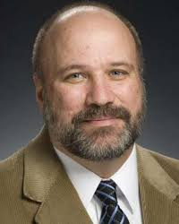
Andrew Houtenville, PhD Director of Research, UNH-IOD
#KFSurvey2020
#KesslerFoundation
#ChangingLives
@KesslerFdn
@kesslerFdn
@KesslerFoundation
Kesslerfoundation.org/2020Survey
Dr. Andrew Houtenville is an Associate Professor of Economics and Research Director of at the Institute on Disability at the University of New Hampshire. He is extensively involved in disability statistics and employment policy research. He has been published widely in the areas of disability statistics and the economic status of people with disabilities. Dr.
Houtenville received his Ph.D. in Economics from the University of New Hampshire in 1997 and was a National Institute on Aging Post-Doctoral Fellow at Syracuse University in 1998/1999. He was also a Senior Research Associate at Cornell University and New Editions Consulting in McLean, Virginia.

Kimberly Phillips, PhD Project Director, UNH-IOD
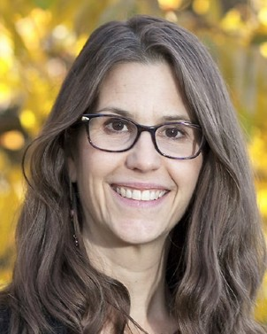
Dr. Kimberly Phillips is a Research Assistant Professor at the UNH Institute on Disability where she conducts grant-funded research related to disability and employment, disability and public health, and rehabilitation psychology. In addition to her work on the Kessler Foundation National Employment and Disability Surveys, she currently serves as Co-
Principal Investigator of the Disability Statistics and Demographics Rehabilitation Research and Training Center and Principal Investigator of the CDC-funded New Hampshire Disability & Public Health Project. She has been conducting research at UNH for the past 11 years.

